Weekly Board Report 24 October 2018
Title I and Title II grant allocations have been delayed this year due to federal audit findings at the Arizona Department of Education’s Grants Management Division. Allocations were finally sent to us last Friday. Both our Title I and Title II grants are down about 15%. Decreases in both grants leave us with about $112,000.00 less than last year. We expected a decrease, but this will be challenging. With our carry forward we should be okay for this year, but changes will be in order next year for programs supported by these grants.

Winter Sports are coming up so please don’t wait until the last minute to obtain your Red Card! See Mrs. Johnson if you have any questions!

Coming this week:
The Camp Verde High School Theatre Arts Guild proudly presents the play, "The Lion, the Witch and the Wardrobe", directed by senior theatre student Bailey Gagnon, This is a retelling of the C.S. Lewis story of four siblings who mysteriously find themselves in a fantastic world of deep magic where darkness and light are at war. The children quickly discover that they have a vital part to play in the outcome of this battle. The play will be presented on Friday, October 27, Saturday Oct. 28; Thursday November 2, and Friday Nov. 3 at 7 pm. Tickets are $3 for students & children and $5 for adults, available at the door.

First Quarter Awards Assembly will be October 25th @ 11:30 AM.

CVUSD is hosting an ELL Parent Night Thursday October 26th 4:00pm-5:00pm at the Multi Use Complex in the library.

The 2nd annual Blood Drive is December 5th from 9:00 A.M. to 1:30 P.M. If you are 16 or 17 and meet the requirements, you are encouraged to donate. Parental consent forms can be picked up in the main office, the attendance office, or from Ms. Westfield in room 101. Your form must be signed and turned in before you donate

CREDIT RECOVERY IS EVERYDAY AFTER SCHOOL & ON FRIDAYS
Sports
Football- Friday @ Sedona
Volleyball-Tuesday @ Home against Paradise Honors (Senior Night)
Boys Soccer-Camp Verde HS is hosting the 1st round of the boys soccer state playoffs on Wed, 10-25 at 6pm. Admission for the game is $10 for adults and $5 for students. Sorry there will be no athletic or family passes accepted.
Cross Country- Sectionals this weekend

Winter Sports tryouts for basketball and wrestling will be Monday, October 30th.

Scholarship Information
Bradshaw Mountain High School - Wed, Oct. 25th, 5:30-7:00 in the BMHS Gym
Northern Arizona Region College Night - Thu. Oct. 26th, 6:00-8:00 in the Flagstaff High School Dome
Both are free and open to all students and parents.

Golden Door Scholars, in collaboration with colleges and universities, is offering full, four-year scholarships to high-performing undocumented students. The application deadline is 10/25/17. Learn more and apply now at www.goldendoorscholars.org.

The Coca-Cola Scholarship is open for exceptional high school students dedicated to leadership, service, and action that positively affects others.
150 Coca-Cola Scholars are selected each year for a $20,000 scholarship.
Deadline is 5pm ET, October 31st.

Earn to Learn Scholarship is now open? It is for any students applying to NAU, ASU, or UA in FA18 or SP19. $4000 and it closes Nov. 8th.

The AZ Milk Producers Scholarship. It is a contest to win $12,000, $10,000, or $8000 based on a milk mustache photo. Contest closes Nov. 21st.

South Verde Math
This week we have a picture of one of the students learning about the quadratic form. One equation is written in the form of a quadratic equation (ax^2 + bx + c = 0) to solve by hand easily, then back substituted to find answers to the original equation. He changed the note at the bottom into a smiley face! : )

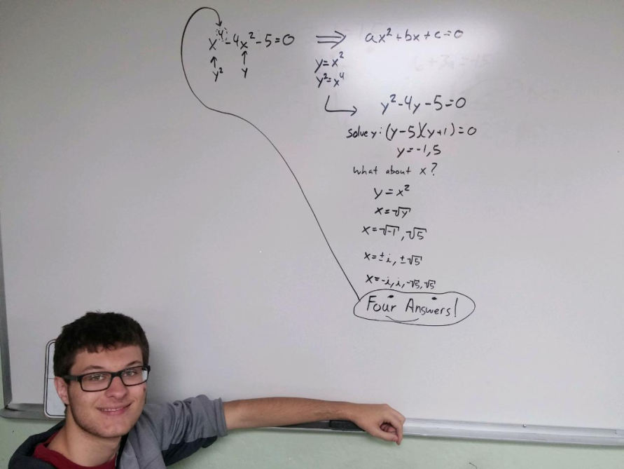

Community:
Three of our students volunteered during Fort Verde Days with the Verde Valley Resale float. Their float received first place in the commercial float category.

Science:
Our trebuchet is close to being finished for the pumpkin chucking contest on October 28th at the Cottonwood fairgrounds. Throwing begins at 12 pm. Anyone is welcome to attend.

Art:
This week in art students drew a distorted self-portrait. They first took a picture of themselves using a program that distorts their image and then they used that image to create their portrait.
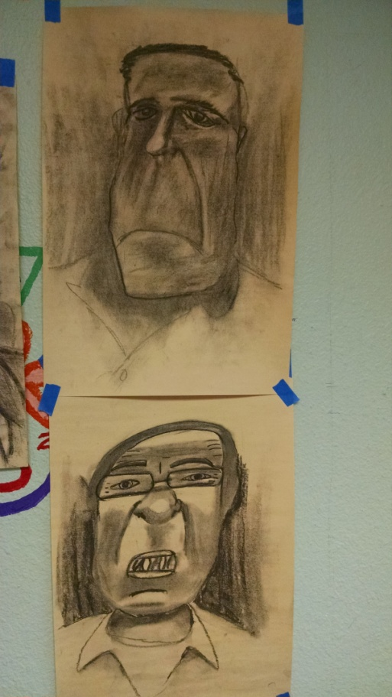

Pictures:
Senior portraits were taken on Wednesday. Below is Jessica Norman with her cap and gown.
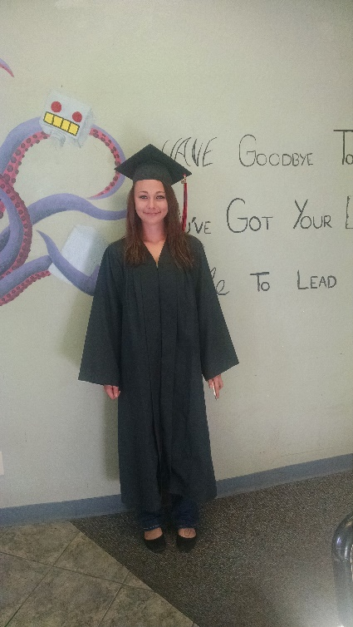

College:
Juniors and seniors are planning their Spring semester at Yavapai College. Soon they will attend a YC day on the Prescott campus where they will be a Yavapai College student for the day.
Basketball try-outs start next week at Camp Verde Middle School. Wrestling and cheer will be getting underway soon as well. The volleyball team took 4th place in their league tournament this past weekend. Way to go girls!!
Quarter 1 ended a week ago, and the awards assembly for it will take place this Wednesday, October 25, in the auditorium starting at 11am. The second dance of the year is happening Thursday. The Halloween Dance goes from 6-8pm in the cafeteria.
This past Friday the Middle School had its monthly professional development. It started with Mr. Howe, Steve Stone, Bryan Pelfrey, and Rick Watkins (not in that order), cooking up eggs and bacon for the teachers. Many brought in casseroles, bagels, fruit, and juice. It was a great breakfast, followed by STAR Reading training.

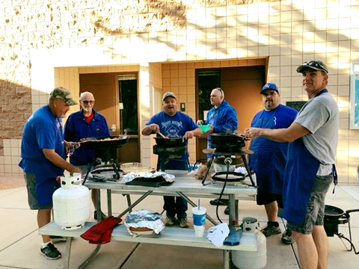
CVMS Teacher In-Service with Breakfast! Thank You Teachers for all you do!!
Kids Against Hunger. A few Camp Verde Middle School students came to volunteer in Cottonwood on October 21st!

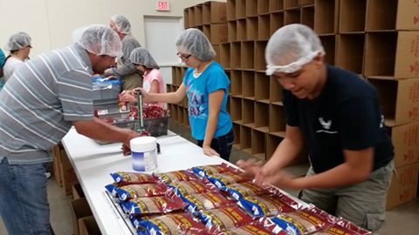

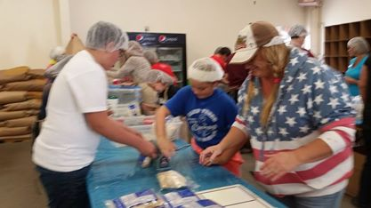

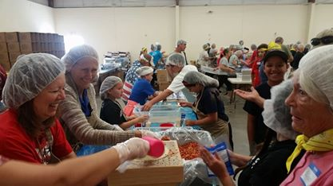

In the Developmental Preschool, Mrs. Mazur taught the students the letter H and they had the opportunity to make some very yummy hummus. From the looks on the students’ faces, they not only enjoyed the activity, they also enjoyed the eating.
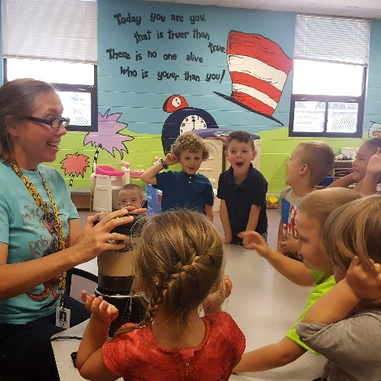
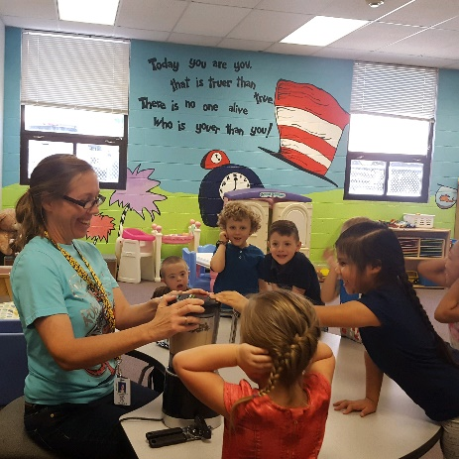

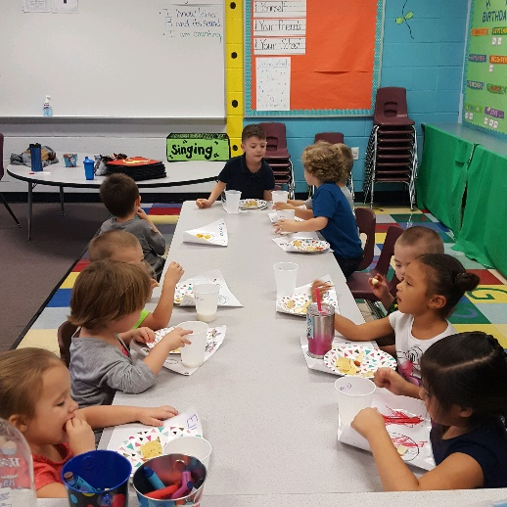

In the Elementary, Ms. Powers has been learning the Being a Writer program the general education teachers are using. She has been able to work on goals and objectives while using this program with her students. This allows her students to write with familiar directives so they can focus on improving their writing skills within the general education curriculum. She has also been having her student practice cursive writing before they begin their weekly writing assignments. This is not only beneficial for the student to learn cursive, but they are also able to enhance their fine motor skills and practice writing higher level sentences with correct grammar and punctuation. Ms. Powers has plans to start working on keyboarding skills soon to help the students with their computer skills.
In Mrs. Weir’s resource room, the students were welcomed back from the long weekend to an activity of cookie icing. The students had to draw faces on their pumpkin cookies as they worked on penmanship skills. During this time, they also began developing stories for their upcoming Halloween activities. What a great way to come back to school after a long weekend.
